CLOUD AZURE ASSIGNMENT

# Create a virtual network with 2 subnets. Each subnet should have 16 Ips . Creating a resource group by logging into Microsoft azure portal .

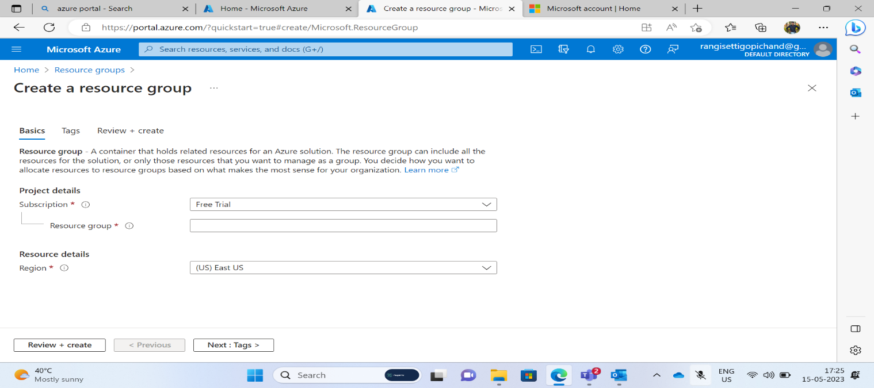

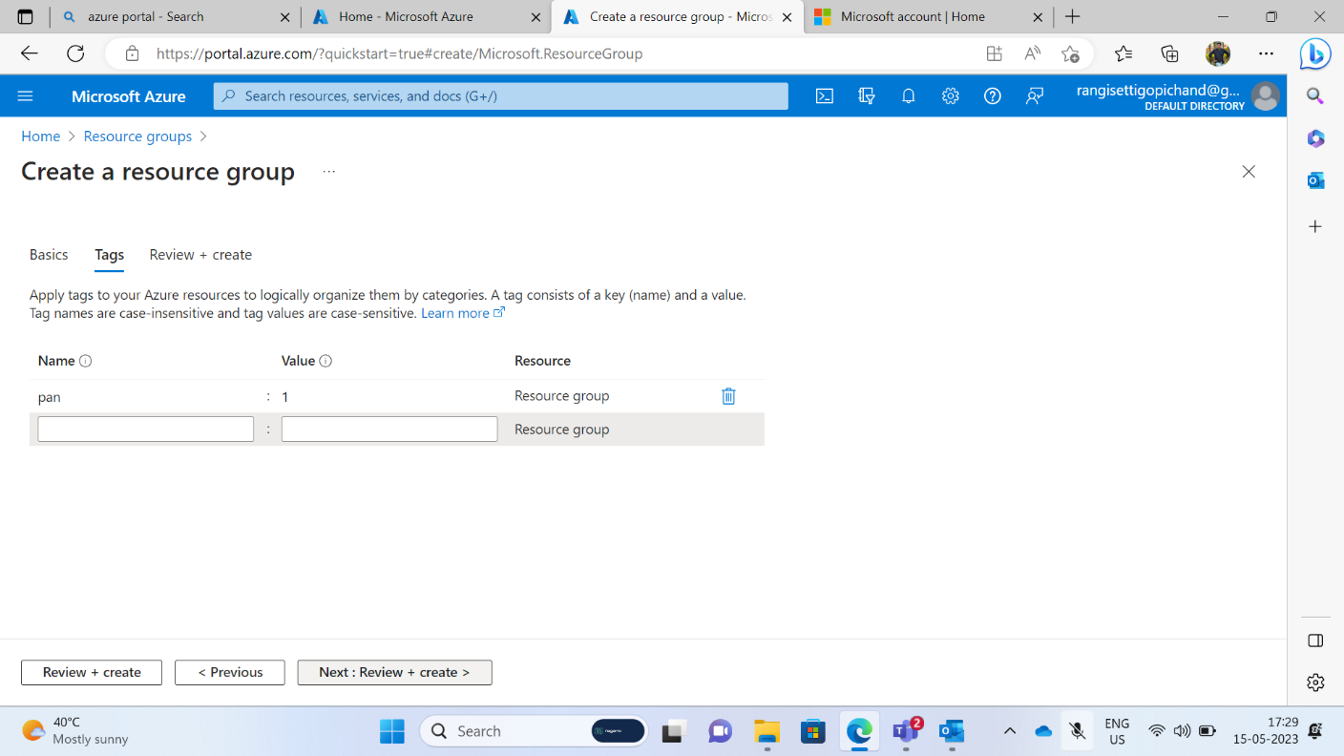

Now resource group has been created.

# Firstly I just created a virtual network

For that created vnet I just added two subnets having 16lps.

* Inside one of the subnets, creating a VM and deploying MVC application code inside it and it should leverage the database on the cloud

Here we create a virtual machine.

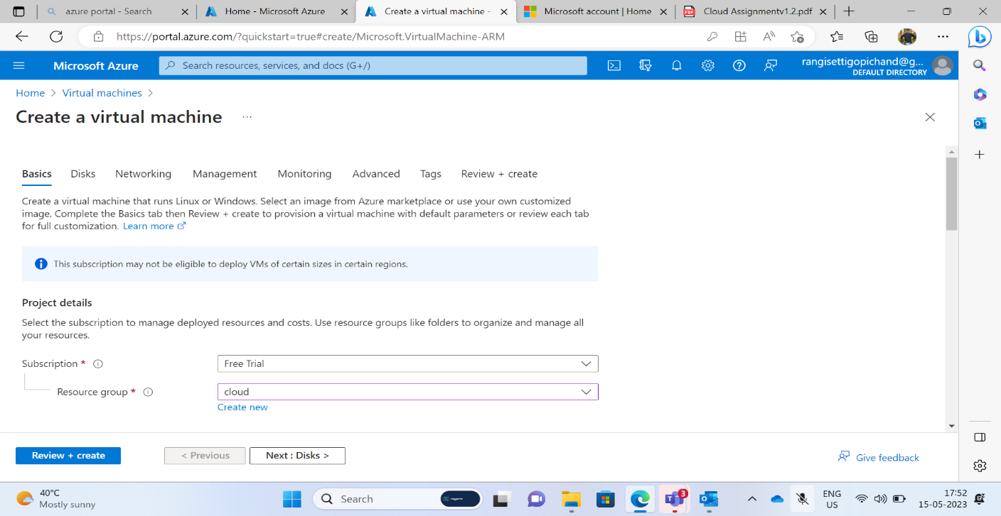

# virtual machine created by choosing window image.

Finally virtual machine has been created by following above steps.

To deploy MVC application in virtual machine we just create a mvc application.

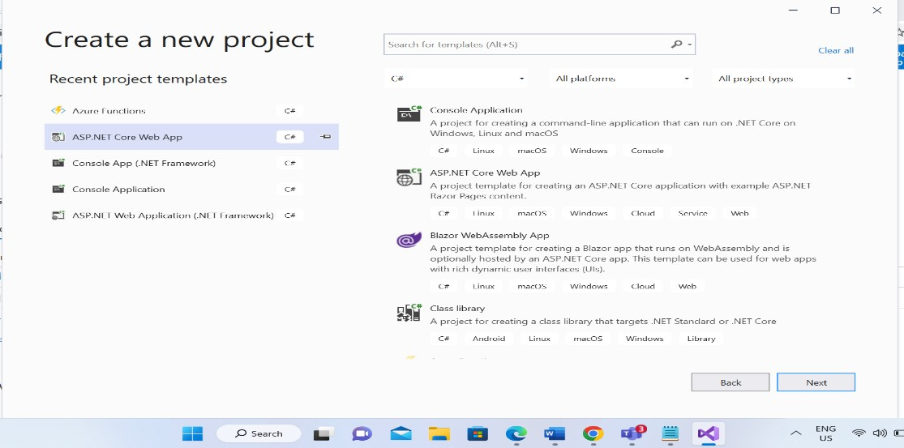

# As by creating the web project .open file explorer and open index.cshtml to show the content that we need to display.

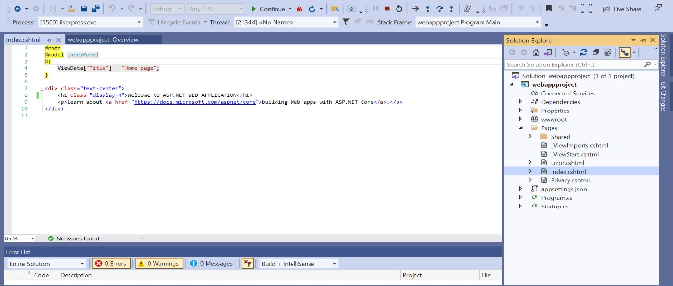

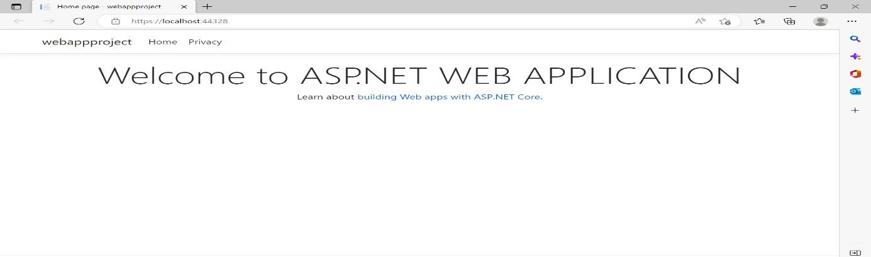

* Deploy the same MVC application to Azure App Service. It should also leverage the database on

the cloud.

Firstly I just created the web service app to deploy my MVC application through the azure portal.

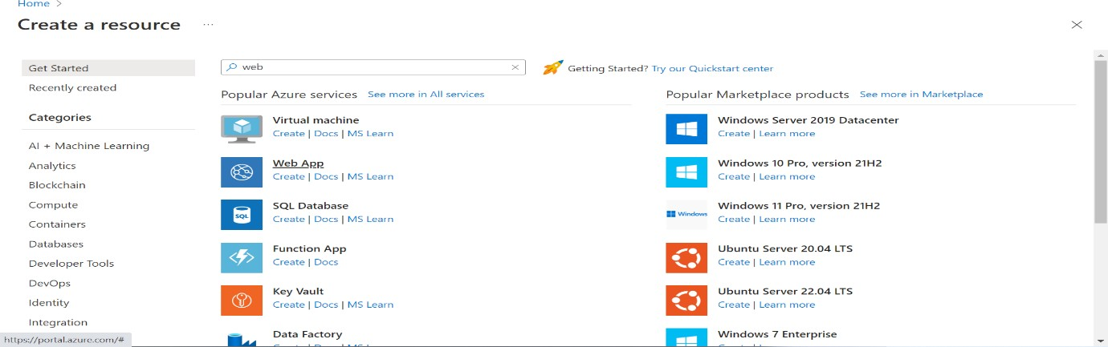

After giving all the requirements to create the webapp service it may create as below.

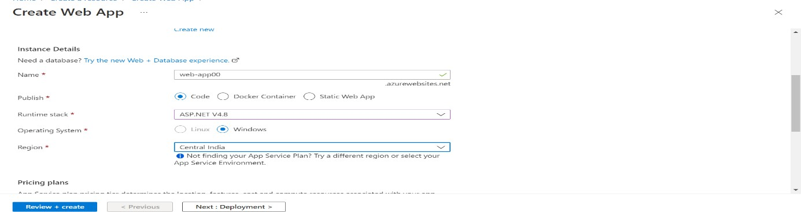

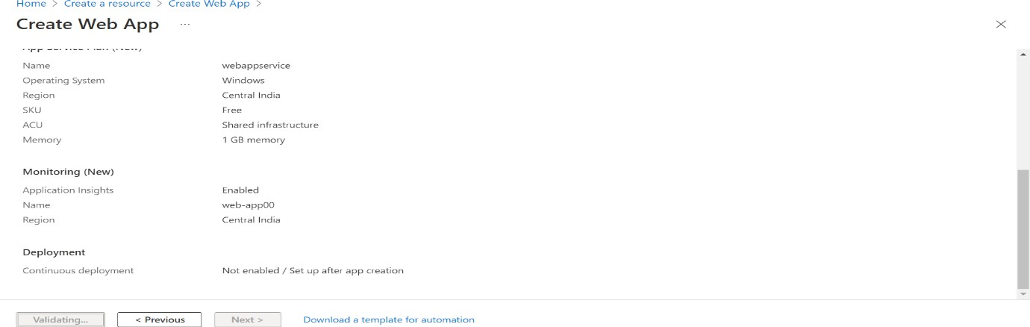Webservice app was created by giving all the pre requirements.

We just created a simple mvc application to trigger to the azure database.

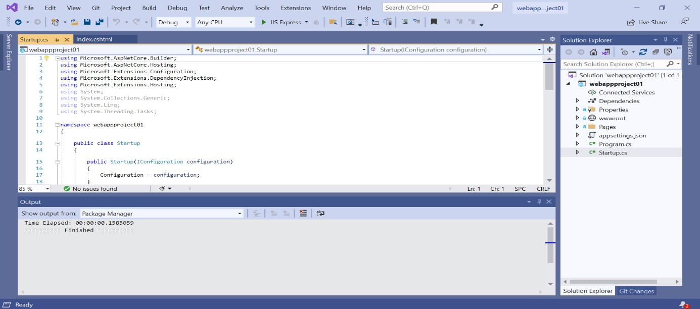

To connect to azure we publish the database of our application globally.

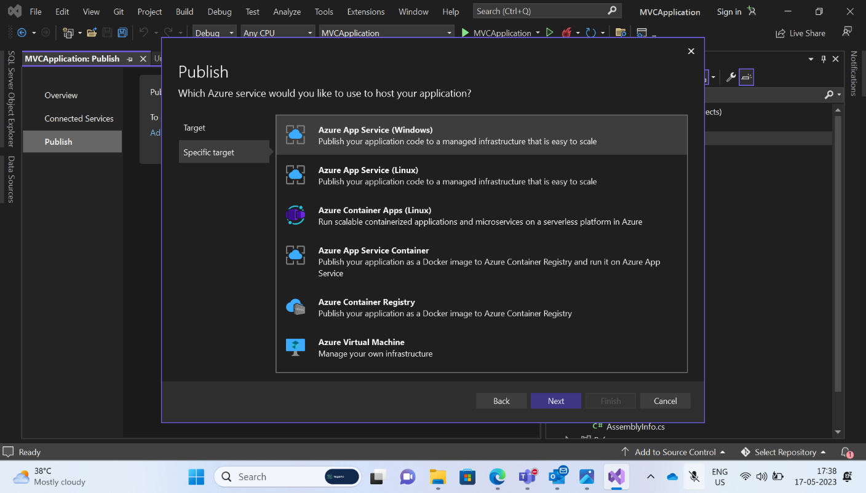

Connection to the azure cloud from the local data base that we publish from the application.

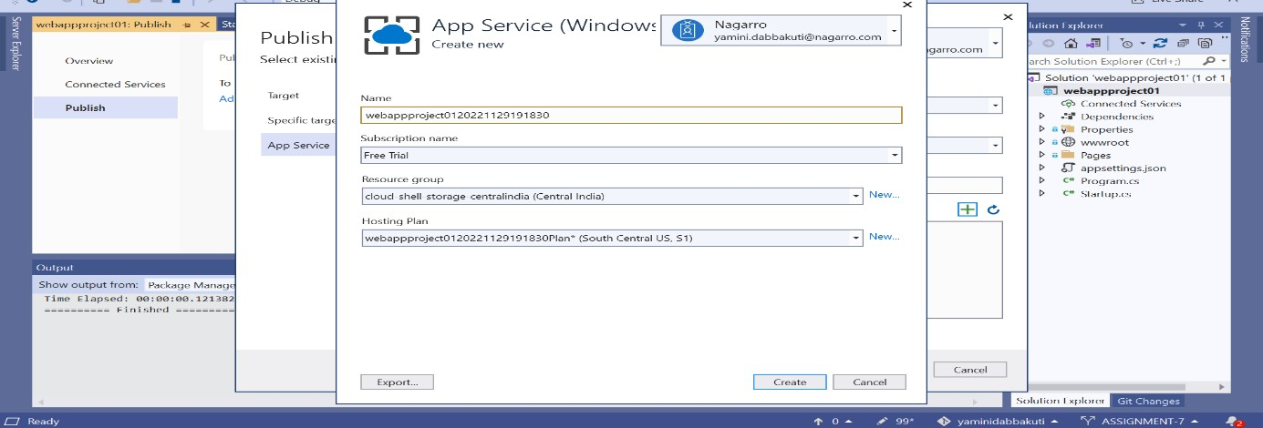

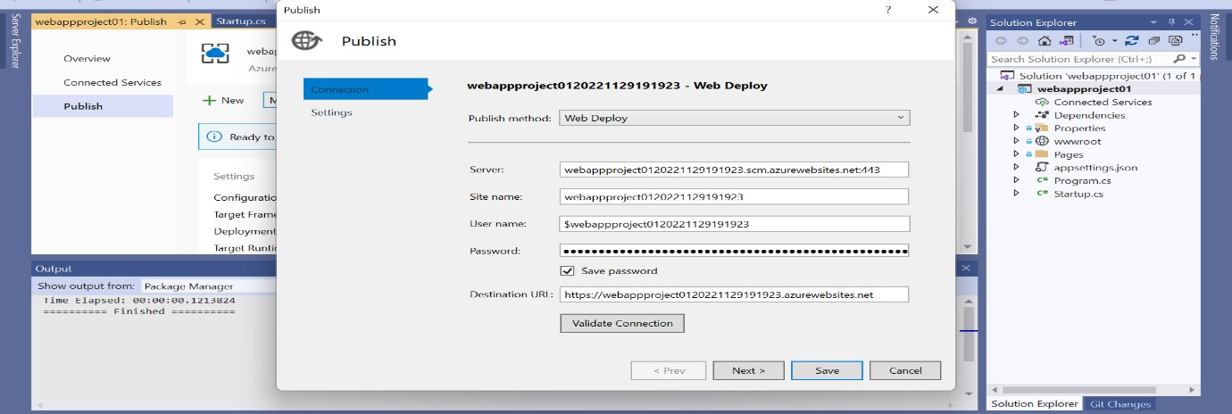Saving all the data of our database server globally to run the application and saving the data.

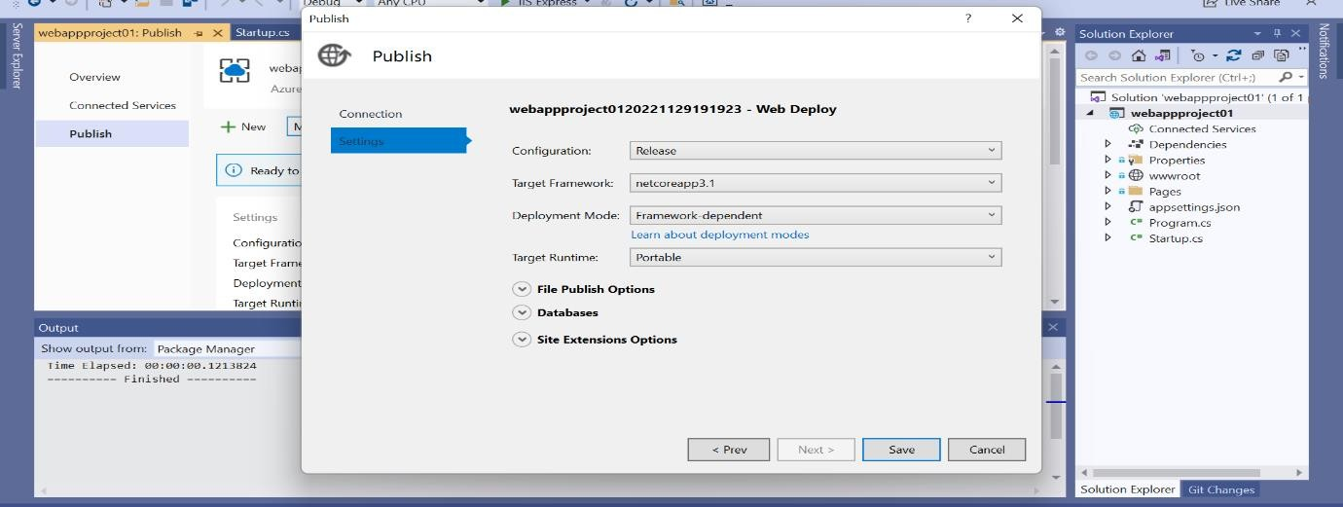

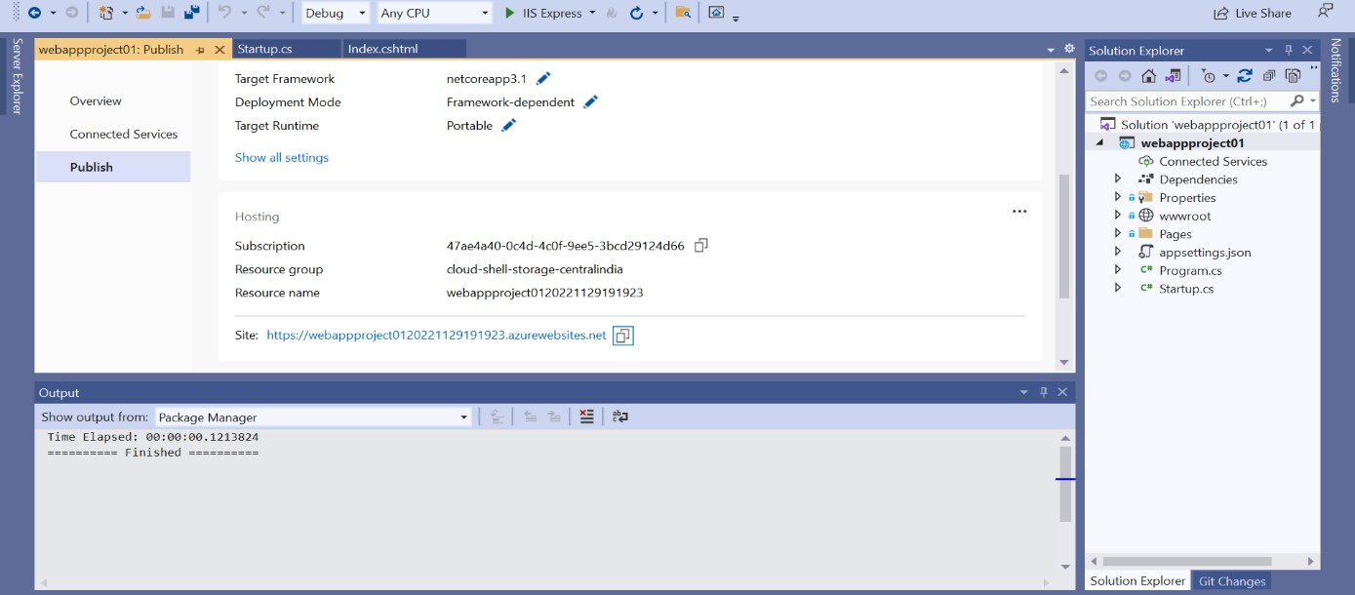

After deploying the MVC application to Azure App Service. It may leverage the database that we created on the cloud.

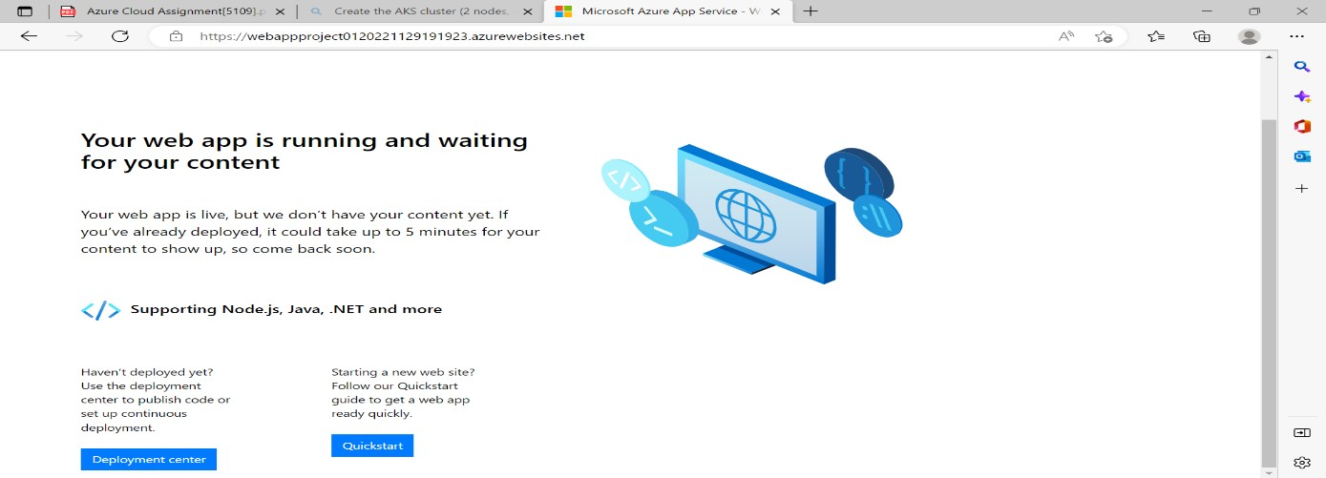

* create the AKS cluster (2 nodes, smallest size VM) and deploy any two services on it. Services

should be accessible from the internet.

Creating the aks cluster by choosing the resource group and the name that we need to create.

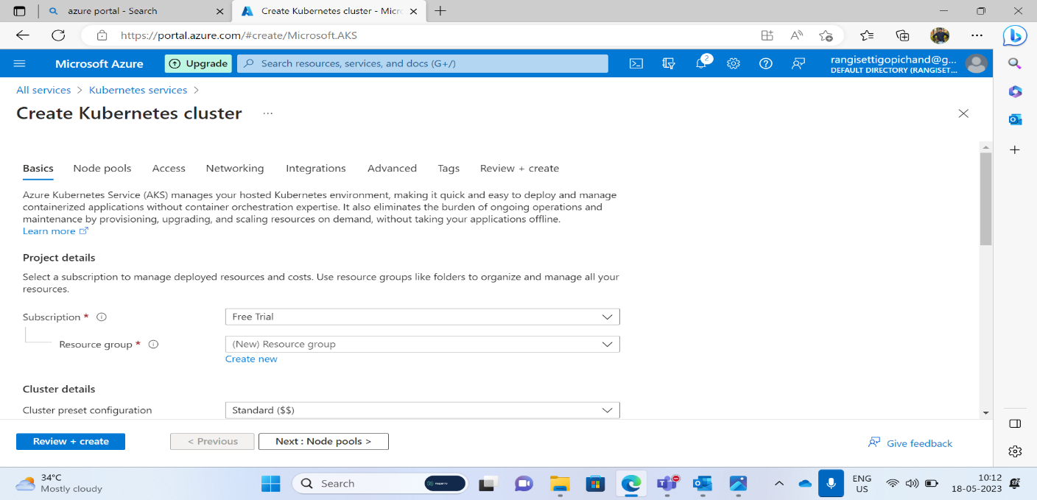

Created the AKS cluster with2 nodes, having smallest size VM.

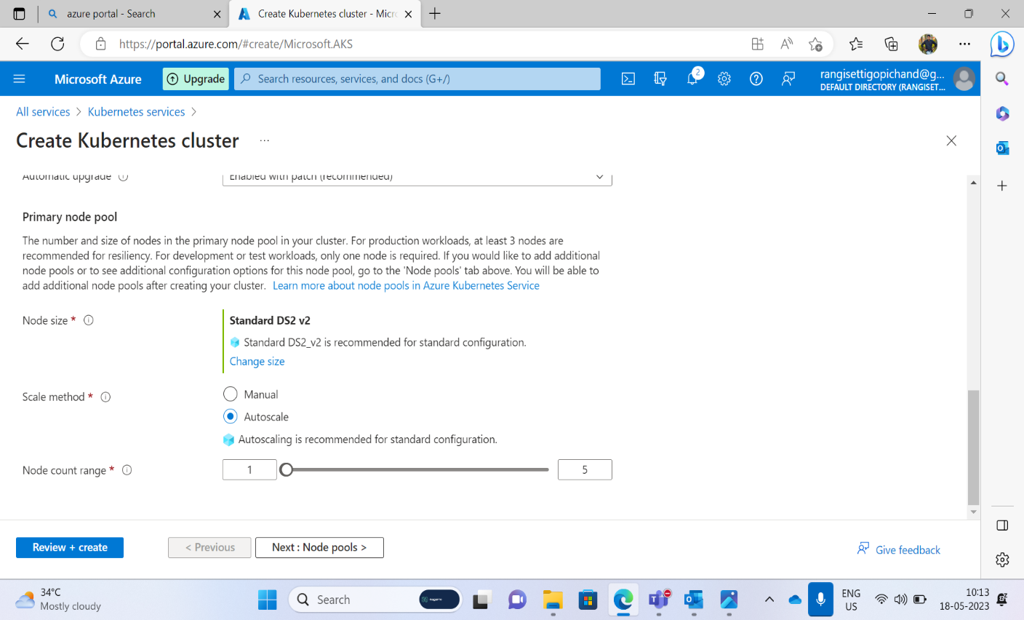

Now the aks cluster was created with all the requirements that we want.

After creating apk cluster open the cloud bash after storing data and all pre requirements.

This was the two services that I want to deploy to the aks cluster that I have created.

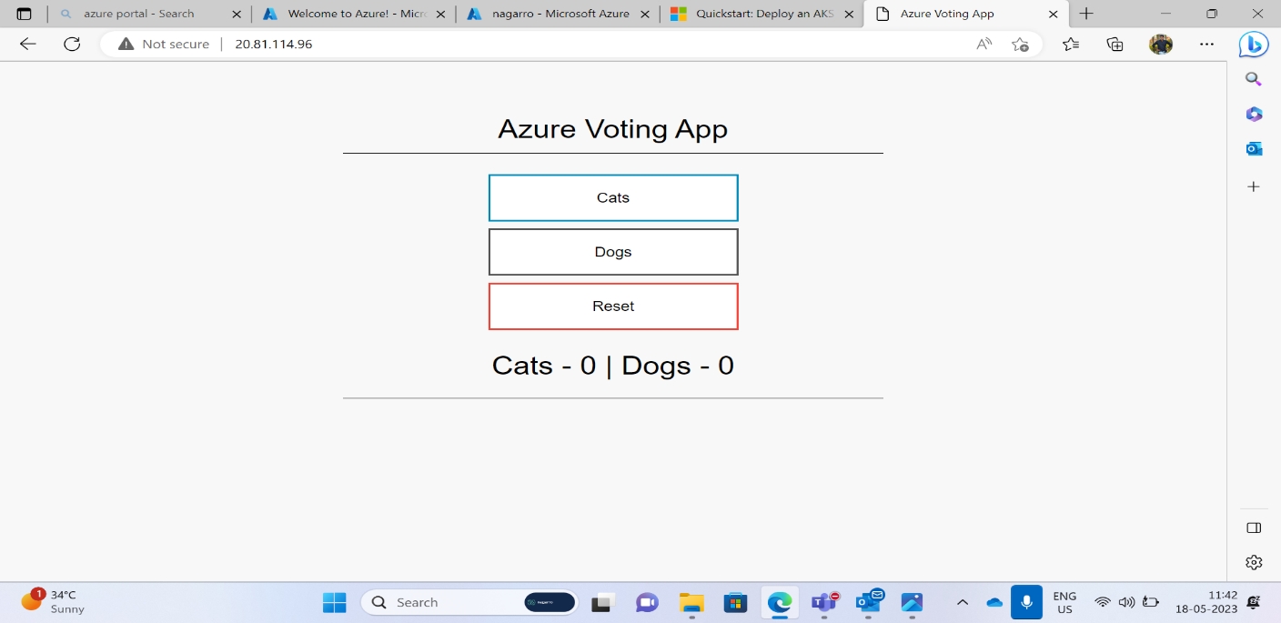

* Create an Azure function that should trigger as soon as you upload a file in the blob storage.

Function should be able to print the name of the file uploaded in the function.

Creating an MVC application to trigger the uploaded file in our application to the azure cloud

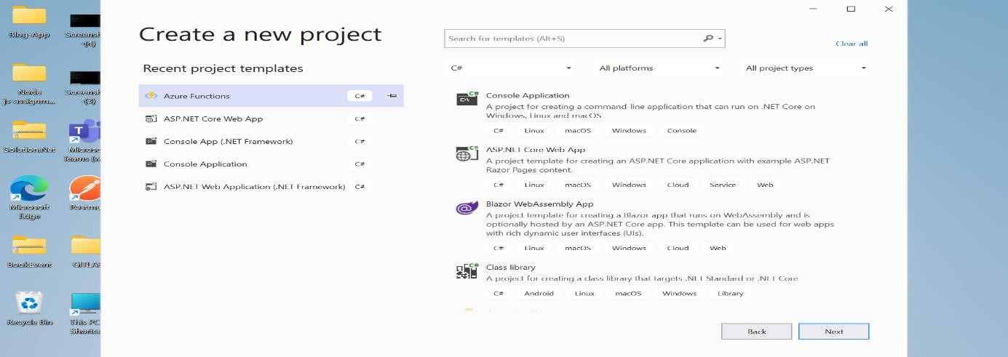

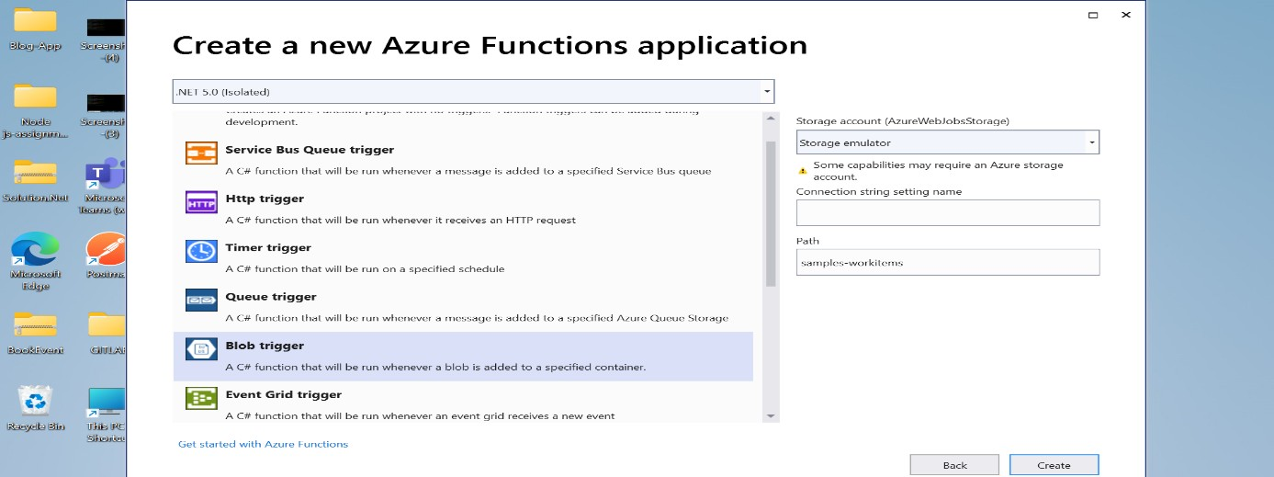

# By clicking the cloud explorer we just created the host and dev to trigger the name, size or any other text that we created and connected the connection string from local setting json file and uploaded file to display when we triggered.

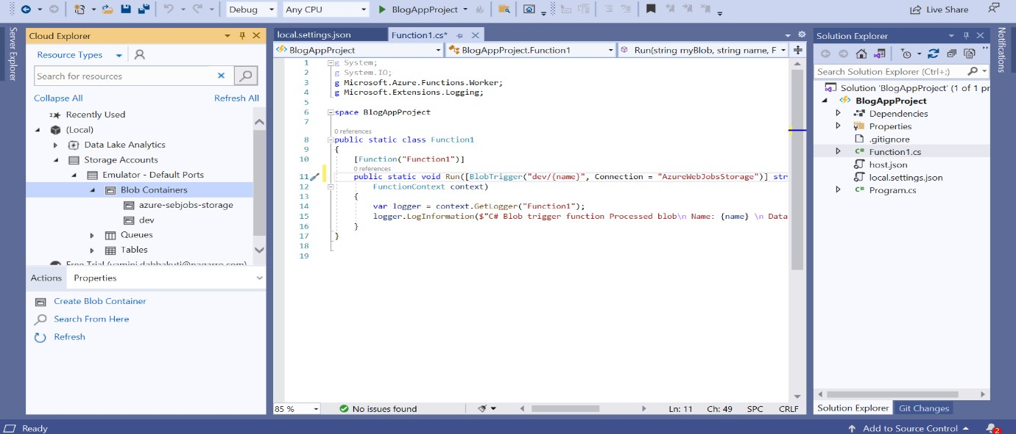

After uploading the file or any other image file to display has been uploaded as below.

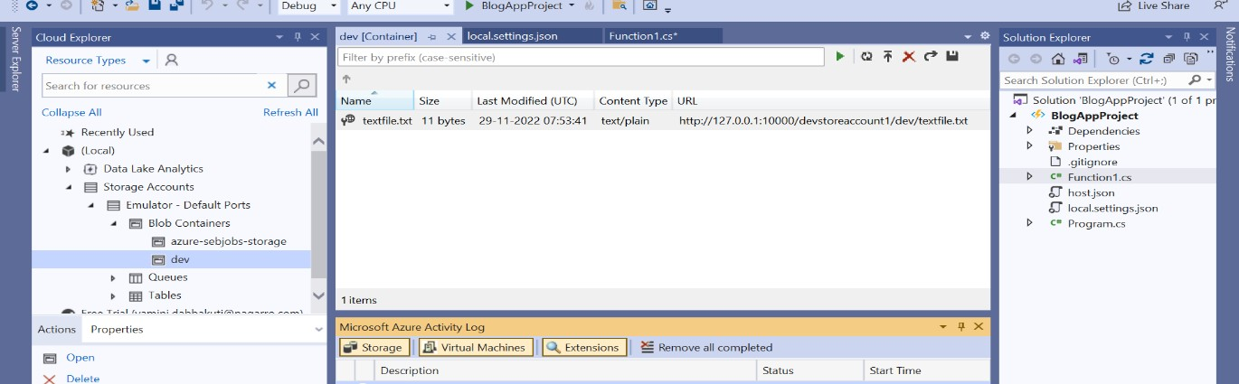

# Finally uploaded storage file has been triggered from the azure function. And printed the same text file that we uploaded in the azure function in mvc application.

